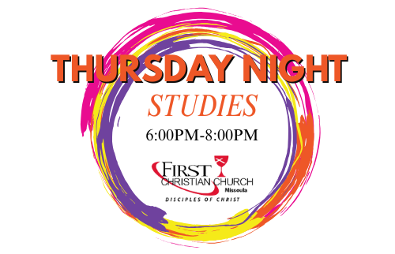
Starting Sept 4, 2025
Join in the exploration of faith as we seek understanding through lessons, discussion and fellowship on Thursdays Nights.
Meal: 6:00pm
Study: 6:30pm
September Topic
Foundations of Faith pt 1
9/4- What is Christianity?
9/11- Communion
9/18- Baptism
9/26- Why do we Worship?
October Topic
Apocalyptic texts in scripture & what they really mean.
Have an Idea for how we can better engage faith? Please connect with Pastor Mat & the Faith Formation Team to explore how to do that!

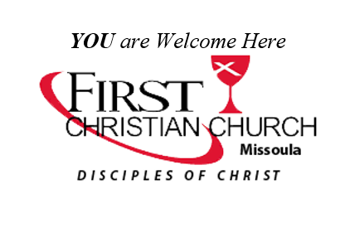
www.fccmissoula.org
2701 S. Russell St.
Missoula, MT 59801
406-549-7221

Fall 2025 Events & More
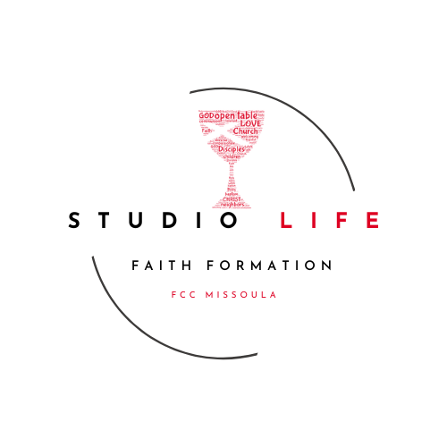
Find ways to explore and grow in your faith this Fall at FCC Missoula!

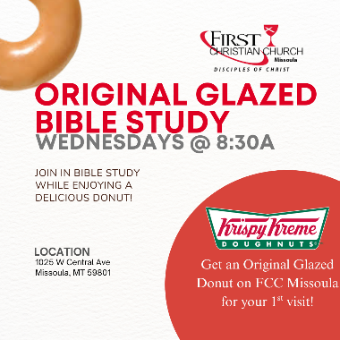
NEW! Original Glazed Bible Study
Wednesdays @ 8:30am
Starting Sept 10, 2025
Join Pastor Mat in Bible Study at Krispy Kreme Missoula. Each week we will be looking at the text for the upcoming Sunday Worship.
1025 W Central Ave
Missoula, MT 59801
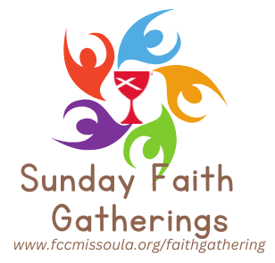.
Sunday Faith Gatherings Return!
Starting Sept 7, our Sunday Faith Gatherings return before and after worship!
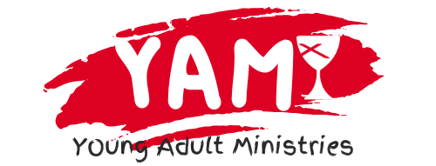
NEW Young Adult Offerings
www.fccmissoula.org/yam
Young adults are invited to participate in a variety of faith events to encourage their continued growth and connection to the Church.
3rd Sundays- Meeting at 2pm at various locations!

Fall Festival
Join in Celebrating Fall as we gather for games, chili, community, and Fun!
October 25, 1-5pm
More info coming Soon!

BINGO
Sat Sept 20, 2025
2pm
$1 split the Pot BINGO
140 Year Celebration
Nov 14-16, 2025
Celebrate 140 years of Ministry here at FCC Missoula! We will be enjoying seeing our Regional Minister and having several meal, worship, and mission opportunities.

Other Upcoming

-Oct 3-4: Mission Coworkers at CRW

-Oct 31: Trunk or Treat at FCC

-Nov 27: Thanksgiving

-Nov 30: Advent Begins!

-Dec 20: Festive Feast: 2pm

-Dec 23: Xmas Eve Service: 6pm

